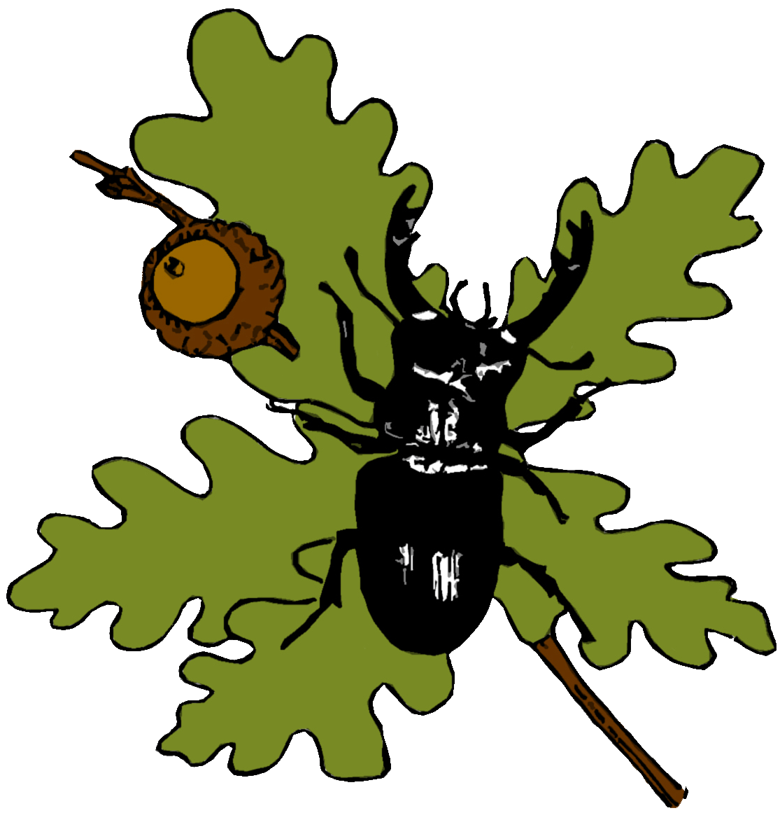
Colchester Natural History Society

5th January 2024

Dear Local Plan Committee,
GREEN NETWORK AND WATERWAYS CONSULTATION
The Colchester Natural History Society wishes to share some comments and concerns regarding the Green Network and Waterways Consultation. This letter is instead of inputting into the various boxes on the consultation website.
Firstly Middlewick Ranges has to come out of the Local Plan immediately and be designated as a nature reserve or country park on account of the exceptionally rich wildlife found there. This area of acid grassland is the largest left in Essex now and the rich assemblage of invertebrates have led it to become a National Important Invertebrate Area – taking on a national significance. Over 1400 invertebrate species have been recorded and 150 species of those have a conservation status. It is also an important green lung for those who live on the south side of town and is a well visited site.
Secondly the Birch Brook Woodland Local Wildlife Site appears threatened by the land being put up for sale. Any housing nearby would lead to much disturbance and degradation of the fabric of the wood, to the actual brook, as well to many species including the important breeding population of nightingales. This area needs protecting as a Green Space
Thirdly the Weir Lane grasslands are an exceptionally rich set of meadows, currently unspoilt and visited by many locals, as seen by the well-walked network of pathways across them. There can’t be an equivalent size of similar grasslands anywhere else in the borough. This whole area is part of the mitigation for the proposed Middlewick development, which will destroy these rich grasslands by ploughing and sulphur application. This whole area needs protecting as a Green Space.
From the wording, there appears to be a presumption that green spaces and waterways are only of interest to the Council for public amenity. Ecological importance and biodiversity barely feature, which is hugely worrying, as there should be more emphasis on managing and enhancement for wildlife. Every open green space and each of the waterways are of great value to wildlife. In recent years the Council has begun steps to manage amenity grasslands for wildlife which is greatly encouraging. There should be more roll-out of the Wivenhoe Green Spaces Project across all of the borough and within a quicker timescale too. By spring next year there will be the new duty on public authorities to have regard to relevant LNRS. The Council needs to demonstrate it is safeguarding wildlife across the borough and fully action any points in the forthcoming strategy.
As always Colchester Natural History is keen to engage with Council officers to ensure Green Spaces and Waterways are sympathetically managed for biodiversity.

Kind regards
Dougal Urquhart
Chair
Colchester Natural History Society
Email – dougalurquhart57@gmail.com;

