Langham Parish Council Response to Regulation 18 Local Plan Consultation: APPENDIX 4
Dedham Vale National Landscape Impacts
Purpose
This paper addresses the Langham Parish Council (LPC) concerns relating to the Impact on the Character and Setting of the Dedham Vale National Landscape (formerly Area of Outstanding Natural Beauty or AONB) and will be incorporated in the larger submission put forward by LPC in the consultation process.

Background
The proposed development is situated immediately adjacent to the Dedham Vale National Landscape (DVNL). It sits between School Road and Park Lane in Langham and within 100 metres to the north of School Road is the Hornestreet Nature Reserve which sits within the Project Area of the DVNL. Additionally the entire northern part of Langham is within the DVNL (see the development area maps below).

National Planning Policy (NPPF) paragraph 176 states that great weight should be given to conserving and enhancing the landscape and scenic beauty of National Landscape. The proposed development, due to its scale, design, and layout together with the massive infrastructure expansion requirements, would have an adverse effect on the undeveloped and open character of the Langham site, and thereby harm the setting of this nationally protected landscape.

Impact
Building in areas adjacent to National Landscapes involves strict planning controls aimed at protecting the natural beauty and setting of the designated area. The design and appearance of the development are not in keeping with the local vernacular and character of the area surrounding the National Landscape. Under the Countryside & Rights of Way (CROW) act, Planning authorities have a legal duty to "seek to further" the conservation and enhancement of these landscapes, which influences decisions on development both inside and outside their boundaries.

The proposed allocation would urbanise the entire parish landscape by introducing a town-sized mass into a historically rural and dispersed linear style settlement. A development of this scale would create a dominant, intrusive block at the gateway to the DVNL. The central farmland sites contribute to the transitional landscape leading towards the DVNL, and the Draft Plan provides no evidence of the allocation’s impact on the Dedham National Landscape setting or rural approaches. The Dedham Vale Management Plan emphasises the importance of rural edges, approaches, and landscape setting.

Increasing visitors to the Dedham Vale is a target for the National Trust but increasing the size of Langham by 350 % in the core will inevitably be a challenge for surrounding areas including the Dedham Vale and Dedham Village in particular. 975 new homes (includes house building stalled by planning conditions) will equate to about 2,500 people and over 2,000 motor vehicles that will likely disturb the tranquillity of the area and increase the visitor numbers dramatically. There are already significant issues with "rat run" traffic in Boxted, Langham and Dedham with this major expansion magnifying the problems.

Furthermore, at the time of the Covid pandemic, Dedham became a focal point for “holiday resort” style visitors to the River Stour at the border of Dedham and Stratford St Mary. This has disturbed the tranquillity of this DVNL location and the village centre. An urban expansion within 3 miles of this site will inevitably magnify this problem.

Not forgetting that a housing expansion of this size will likely give rise to light pollution and impact the Dark Skies initiative in a national protected landscape.
In effect we will end up with an urban extension with the prospect of further urban sprawl as the next Local Plan is eventually rolled out in 7/8 years time.

Impact on the Black Brook and Potential flooding in the DVNL
Langham Water Recycling Centre (WRC) takes sewage from Langham and much of Boxted. Boxted has a new housing allocation of 150 dwellings in the new Local plan. In total including Langham we are looking at 1,125 new homes connecting to the Langham WRC. If the Langham WRC is ever upgraded to cater with these new volumes, and there are no plans to upgrade it before 2050, there are potentially serious flooding issues affecting the Black Brook and the DVNL.

Following treatment of the foul water at the Langham WRC the water is discharged into the Black Brook which also collects natural ground drainage and disperses water on its journey to the River Stour, travelling through Langham and eventually running through Dedham where it discharges into the River Stour. The Black Brook water level runs high through Dedham during wet weather times and the impact of the increased output from the Langham WRC, due to increased housing capacity, could lead to downstream flooding in the DVNL. Also, natural surface water drainage from the new developments will also add to additional water entering the Black Brook through the local ditch drainage networks.

Non-Compliance with Local and National Planning Policies
The proposal fails to comply with the following policies:
- Draft Local Plan Policy NP2: Dedham Vale National Landscape
- National Planning Policy Framework (version 2023) paragraph 176
Planning Considerations associated with a National Landscape
- Impact on Setting: Development proposals located outside a National Landscape boundary but which might affect its setting or character should be subject to scrutiny. Local planning authorities (LPAs) must consider the potential impact on the designated area, not just the development's immediate surroundings. (See the following Development Area and the DVNL Project Area which identifies the expansion area immediately north of School Road).
- Stricter Controls: Planning applications face more restrictive controls and tighter permitted development rights compared to other areas. Proposals must demonstrate a positive contribution to the landscape, ecology, and existing heritage.
- New Duty: Recent legislation, the Levelling Up and Regeneration Act 2023, strengthened the duty on relevant authorities to "seek to further" the purposes of Protected Landscapes, making the duty more proactive than the previous "have regard to" requirement.

- Impact on tranquillity: The impact of a development on the tranquillity of a national landscape is a significant planning consideration in the UK, particularly within protected areas. Planning policies should aim to conserve and enhance the natural beauty and special qualities of these areas, and new development must be sensitively located and designed to avoid or minimise adverse impacts.

- Protected Status: National Parks and National Landscapes have the highest level of protection in the planning system. Local Planning Authorities (LPAs) have a statutory duty to "seek to further the purposes" of these designations, which includes the conservation and enhancement of their natural beauty and tranquillity. A key attribute of these landscapes is tranquillity, generally defined as an area relatively undisturbed by human-caused noise or visual intrusion, where natural sounds and sights (like birdsong, flowing water, or dark night skies) are predominant.

- Major Development: While there is no rigid definition of "major development", projects should be assessed to see if they have the potential for a serious adverse impact due to scale, character, or nature. Major developments within these protected landscapes should be considered inappropriate unless the need for the development can be demonstrated to outweigh the need to retain the special qualities of the area. The potential for a serious adverse impact on natural beauty, including tranquillity, is a key factor in determining if a development is "major".

- Cumulative Impact: Even small-scale changes, if numerous, can lead to the "piecemeal erosion of distinctiveness" and tranquillity

Map
Development Area

Langham and Boxted proposed new settlement boundaries (black) in relation to the DVNL border (purple) and the Stour Valley Project Area border (turquoise).

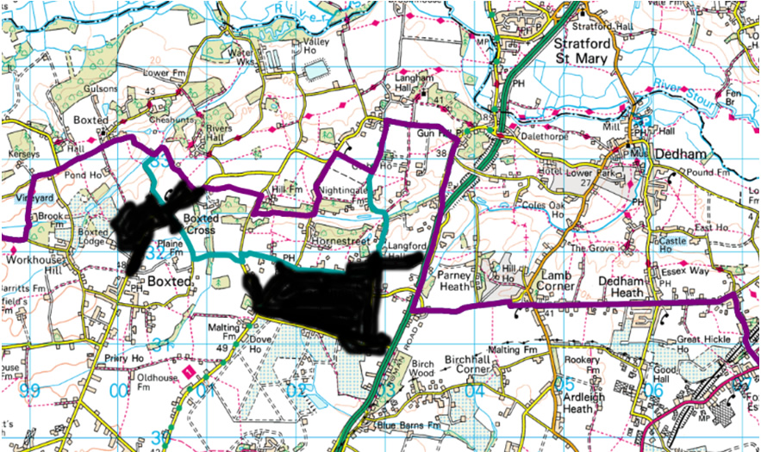

In conclusion, the negative effects of the proposed strategic housing development on the character and setting of the AONB and surrounding environment are considered to be significant. It is therefore, requested that the City Council reconsiders the draft rural housing allocations, in favour of a solution(s) which allows for a sustainable form of development to be delivered.

Langham Parish Council
12th January 2026

