Langham Parish Council Response to Regulation 18 Local Plan Consultation: APPENDIX 5

Langham Public Transport Report

Current Public Transport Services in Langham

- Public Bus Service
The following details public bus service constraints in Langham and show where the draft plan fails to locate development where there is or could be genuine access to sustainable transport being contrary to NPPF paras 109 and 110, its requirements being to reduce the need to travel and promote public transport use. Most buses going south into Essex are run by commercial businesses without subsidy from Essex County Council. The 81/81A Langham service is a ‘one bus’ only regular service that runs through the village from Manningtree to Colchester and is an ECC supported service operated by KonectBuses, an independent private company. If the bus breaks down there is no follow-up bus available causing a cessation of the service for the remainder of the day. Whilst this minimal service provides an important amenity for the village it is not fit for purpose in terms of flexible social/shopping use or for anyone wishing to commute especially from Colchester Railway Station.
Travelling north from Langham there is a skeletal bus service 93/93A and a one bus a day service X93 which both give minimal travel options to and from Ipswich.

According to the LPC Village Amenities Survey 2021 the 81/81A service is predominantly used for personal or social journeys and not for commuting. This is a Monday-Saturday service with no service on Sundays or bank holidays. There is approximately 2 hours between successive buses during the day and the timetable does not render itself a viable option for commuters using railway services from Colchester Station. For instance during the early morning rush hour there is just one bus the 07.37 hrs and returning in the evening the last and only peak hour bus from Colchester railway station to Langham departs at 17.49. Even if commuters could catch the only outward bus at 07.37 am this does not meet the need for commuters needing to be “at their desk” for a normal start time of 09.00hrs. It would be almost impossible for them to make the 17.49 bus connection to Langham in the evening especially if travelling from London.
There is no public transport from Langham to the widely used GP service in Ardleigh (3.2 miles away), nor to the Park and Ride service (4.5 miles away), or to the high employment zone at Severalls (3 miles away). The timetable is not frequent enough for bus travel to be a viable and successful option for travel to Colchester Hospital or other essential services. With no Sunday service the risk of social exclusion is increased and this lack of service also promotes the use of additional cars, as the only transport option, on a Sunday apart from taxis.

The 93 bus service (Colchester to Ipswich) is not a viable option for commuting north of Langham as to access this service the only bus stop is at Langham Oak bus stop which is situated on the edge of the village literally on the A12 trunk road. There would need to be major changes to this trunk road junction to accommodate this service leaving the A12, negotiating the very narrow entrance to Park Lane in order to reach a central bus stop in Langham village. Additionally, there is no bus stop on the other side of A12 to cater for the return journey and also no safe way to cross the A12 as a pedestrian in order to get back into Langham.

2. School Bus Service
The current school bus service is operated by First Essex 694/East Bergholt High School (outside catchment area) which is a dedicated school bus service operating term time Monday-Friday aligning itself with East Bergholt school dates/times this school being approximately 7 miles away. It serves pupils at stops in Langham for morning pick up and afternoon drop-off and operates on school days only, Mon-Fri term time.
Pupils who meet the distance criteria can receive financial assistance when using the 81/81A service to other schools. As there is no senior school in Langham the significant increase in senior school age children arising out of PP37 and PP38 needing to travel conflicts with para 111(a) of the NPPF.

3. Taxis
To use taxis to plug the gaps in the bus timetable is expensive and financially prohibitive for many people, the return fare from Langham to Colchester city centre and Colchester Hospital being £29.80 and £23.60 respectively. NPPF para 110 clearly state that “development must be located where there is a genuine choice of transport modes”. Langham is a rural village with poor and costly transport options, so this requirement outlined in the NPPF is not met.

4. Railway Services
There is no railway station in Langham, the nearest ones being Colchester North and Manningtree (both 5.8 miles away) where trains to and from London or other commuting areas can be taken. The routes to both stations from Langham are through rural lanes being very unsuitable for commuter journeys. The NPPF highlights the need for sustainable transport in para 110. This would clearly not be achieved by identifying Langham suitable for development.

5. Cycling/Walking
The draft plan conflicts with NPPF para 110-113 because Langham Lane linking the village with Colchester, provides no safe or suitable walking or cycling access—lacking pavements, lighting and cycle provision and in addition is presently dominated by heavy farm and industrial traffic, making active travel impossible. Also, given the distance from Colchester and other sustainable settlements, such highway upgrades would not be practical or viable to achieve suitable modal shifts in favour of sustainable travel, even if the infrastructure could be provided, which is unlikely in any event.

6. Requirements to meet the extra demand for public buses including Commuters (travelling in a southerly direction towards main services in the Colchester area)
Referring to NPPF 109, 110, 111(a) & (c) 117 and 118 — The draft Local Plan fails to secure adequate public transport connectivity: there is no plan to provide a frequent bus service despite the importance of bus access for sustainable travel in this area. The following outlines the current situation in Langham:-
Using the ONS 2021 census 900 new dwellings would produce the need for 93 new daily bus places with 56 of these being needed in the peak period of 07.00-09.00 hrs. According to ECC guidance (*) on proposed new large developments, the limited bus services through the village would render revised requirements and mitigations are likely, as follows:-
a. New or enhanced bus service frequency during key commuter periods between Langham and Colchester Station in order to accommodate significantly increased demand from new residents commuting, to avoid overcrowding, ensure service is viable and attractive vs car travel.
b. Better public transport infrastructure in village such as improved/wider footpaths, safe walking routes to bus stops, shelters, raised kerbs, real time information at stops. ECC would expect Developers to fund all this.
c. Bus stop placements close to new dwellings to ensure walking distance is acceptable (400-800m). If stops are too far commuters will prefer private car use - planning policy does encourage accessibility.
d. Travel Plan required as this would be a large scale development.
e. Contribution to new or diverted bus routes if existing routes do not pass near the new dwellings or existing frequency is insufficient. For example routing an existing service so it serves the new site.
f. Modal share sustainability targets may be agreed as for large developments ECC expects this.
g. Integration with rail travel by ensuring good connectivity to Colchester Station by ensuring bus schedules align with train arrivals and departures so that train commuting.
* Local Transport Plan (LTP), ECC Developers Guide to Infrastructure Contributions, Sustainable Modes of Travel Strategy,Transport Assessments and Travel Plans

7. Phased Public Bus Growth over the Plan Period
To meet the anticipated public bus growth over the Plan period, a phased approach would be necessary. Table 1 with its key assumptions outlines how this could work for journeys going in a southerly direction where most services are accessed with cost implications and for completeness Table 2 outlines how phasing could work travelling north from Langham (but used much less for essential services, apart from return journeys to Ipswich Hospital). The draft Local Plan fails to comply with NPPF paras 109, 110, 111, 115, and 118 in this regard because it does not identify or cost measures to improve bus services or public transport connectivity. In a rural village like Langham, where sustainable travel options are limited, the absence of policies supporting enhanced bus frequency, route coverage, or infrastructure improvements, undermines the plan’s ability to deliver genuinely sustainable development.
Table 1 — Langham, Colchester: Phased Southbound Bus Service Enhancements (2029–2037)

Year | Cumulative dwellings | Recommended service change | Extra vehicles (year) | Cumulative vehicles | Indicative annual cost range
2029 | 100 | Add peak vehicle; hourly to ~45–50 min headway | 1 | 1 | £60k–£90k
2030 | 200 | Increase daytime frequency (~30–40 min) | 1 | 2 | £120k–£180k
2031 | 300 | Add early-evening trips; retime for new streets | 1 | 3 | £180k–£270k
2032 | 400 | Add 2nd peak vehicle; consider express peak runs | 1 | 4 | £240k–£360k
2033 | 500 | Improve Saturday daytime frequency | 1 | 5 | £300k–£450k
2034 | 600 | Introduce basic Sunday service | 1 | 6 | £360k–£540k
2035 | 700 | Extend peak journeys to employment or education sites | 1 | 7 | £420k–£630k
2036 | 800 | Increase daytime frequency; target ~30 min headway | 1 | 8 | £480k–£720k
2037 | 900 | Network review; possible second route or trunk upgrade | 1 | 9 | £540k–£810k

Assumptions:
Assumes 900 dwellings delivered at 100 per year (in approximate alignment with Masterplan comment that “the site will be completed within the plan period”).
Average household size = 2.4 persons per dwelling; Car ownership rate = 1.5 cars per household; Public transport mode share = 10% of residents; Each bus carries 50 passengers at full capacity; Service frequency adjustments are rounded to the nearest half-hour increment; Traffic congestion effects on bus journey times are not explicitly modelled; Build-out of dwellings is assumed to be linear over the period.
Sources:
• DfT TAG Unit M3.1 — residential trip-generation and mode-split guidance.
• Essex County Council Local Transport Plan (LTP4) and Bus Service Improvement Plan (BSIP).
• Confederation of Passenger Transport (CPT) Bus Cost Index for marginal cost estimates (£60–90k/vehicle-year).
• Approx. 1 peak vehicle per 100 dwellings: common Section 106 / BSIP practice for rural corridor enhancement.
(Figures are indicative and for planning purposes only and show Sources & assumptions (summary)
Table shows recommended incremental service changes, additional vehicles, and indicative annual operating cost range.
Table 2 - Impact of Building 900 New Dwellings (2029–2036) in Langham, Colchester on the 93/93A Bus Service (Northbound towards Ipswich)
Year | Cumulative Dwellings Completed | Estimated Additional Passengers per Day | R’mmended Service Change Mon-Fri | R’mmended Service Change (Sat&Sun) | Indicative Additional Annual Operating Cost (per year)
2029 | 100 | 24 | Add 1 morning peak journey | Add 1 mid-day journey | £60k-£90k
2030 | 200 | 48 | Add 1 morning and 1 evening peak journey | Add 1 morning and 1 afternoon journey | £120-£180k
2031 | 300 | 72 | Increase peak frequency by 1 bus per hour | Increase service by 1 bus per 2 hours | £120-£180k
2032 | 400 | 96 | Increase peak frequency by 2 buses per hour | Increase service by 1 bus per 2 hours | £180k-£270k
2033 | 500 | 120 | Add 1 additional peak journey morning and evening | Add 1 morning and 1 afternoon journey | £180k-£270k
2034 | 600 | 144 | Increase peak frequency by 2 buses per hour | Increase service by 1 bus per 1.5 hours | £180k-£270k
2035 | 750 | 180 | Add 1 morning and 1 evening journey; increase off-peak frequency | Increase service by 2 buses per day | £240k-£360k
2036 | 900 | 216 | Increase peak frequency by 3 buses per hour; consider express service | Increase frequency to hourly service | £270k-£400k

8. Increased School Bus Requirements
The draft Local Plan fails to identify or cost additional infrastructure required to accommodate increased school travel demand, including transport improvements, thereby undermining sustainable access and plan viability. The following position in Langham shows how guidance in NPPF paras 109 and 111 is not being taken account and the need for travel assessment/travel plans (para 118).
If Langham grows by 900 dwellings between 2029 and 2037, school travel demand will rise steadily, requiring additional transport capacity in line with pupil generation. In the early years (up to around 300 dwellings), existing school buses and routes to Langham Primary, East Bergholt High, and Colchester secondary schools could largely absorb the increase. Beyond 400–500 dwellings, new bus routes or extra vehicles would be needed to maintain safe and reliable journeys, particularly for secondary pupils travelling into Colchester. By full build-out in 2037, an estimated six to eight dedicated school buses would be required in total—roughly double current provision—along with new pick-up points, improved turning areas, and footpath links to ensure safe access for pupils across the expanded village. Table 3 illustrates the growth.

Table 3

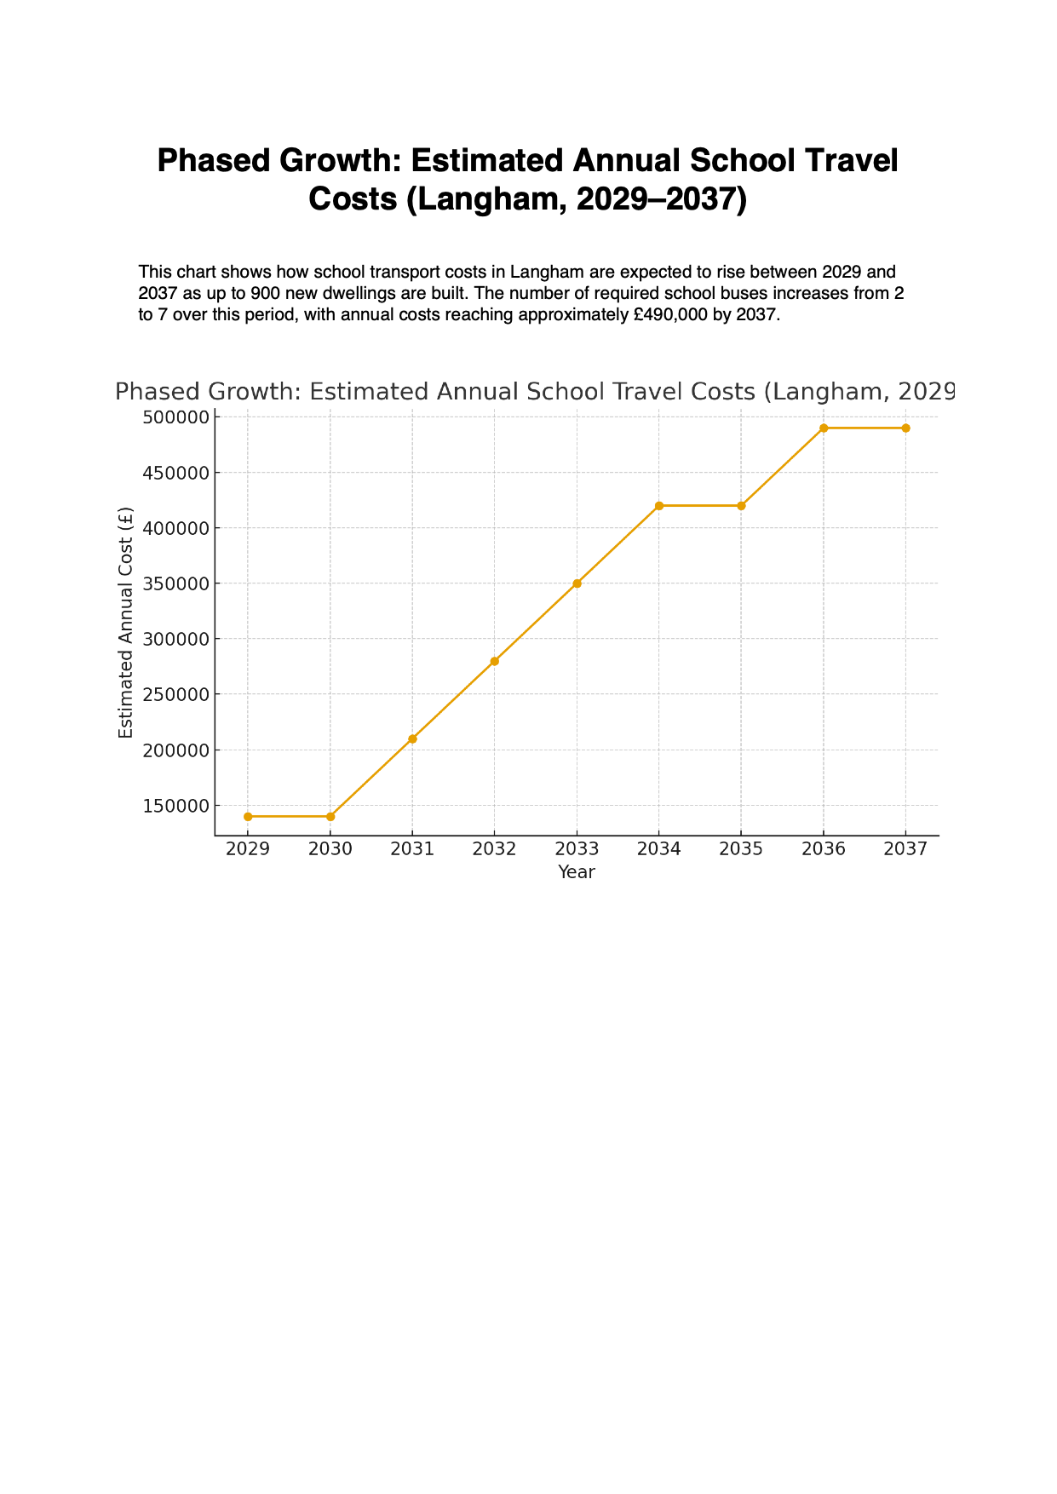

9. General Implications
The public travelling implications of 900 extra dwellings in Langham are numerous. They include cost, traffic and highway network impacts, road safety and accessibility, environmental and amenity impacts, operational and social implications, planning, land use etc.

10. Conclusion

Referring to Colchester Local Plan Policy DP17 (“Accessibility and Access”) and the Langham Place Policy (para 6.177–6.179) the building of 900 new dwellings in Langham (2026–2041) has practical delivery constraints for bus services, public transport infrastructure, and walking and cycling sustainable travel obligations. The draft Plan acknowledges that Langham has limited access to public transport and few local facilities”. It states that new development must “ensure good connectivity to existing footways and services”. Given the distance from Colchester and other sustainable settlements, such connectivity by sustainable modes of transport such as frequent and rapid bus services and walking and cycling infrastructure is considered to be an unrealistic proposition.
Therefore, any large housing proposal at Langham would not meet Local Plan or national transport policies since the village is explicitly described as lacking transport access it and realistically would not be provided either. This situation helps to clarify the unsuitable nature and location of the strategic housing allocation, which needs to be deleted from the Plan and directed to a more appropriate location in line with the draft Plan’s settlement strategy and national planning guidance for achieving sustainable development.

Langham Parish Council
12th January 2026

