Langham Parish Council Response to Regulation 18 Local Plan Consultation: APPENDIX 8
Langham Landscape and Heritage Report

1. Landscape Importance and Village Character
These central farmland sites form part of the historic landscape core of the village, separating Langham Moor and Langham Wick and providing the open rural sense of place that frames historic lanes and listed buildings. This land has shaped Langham’s identity since the Middle Ages. Development of this scale would fundamentally alter and materially detract from the landscape form, character, and rural identity of the village, conflicting with NPPF 130, 135.
2. Visual Impact and Landscape Character
The proposed allocation would urbanise the parish, introducing a town-sized block visible from School Road, Park Lane, Moor Road, Wick Road, and multiple footpaths. Long-established hedgerows, historic field boundaries, and traditional field patterns would be lost or subordinated. Continuous built form, engineered roads, and street lighting would intrude into a tranquil, open landscape and into views toward the Dedham National Landscape, Langham sitting in the setting of the protected landscape, contrary to NPPF 130–135, 191.
3. Footpaths and Community Value
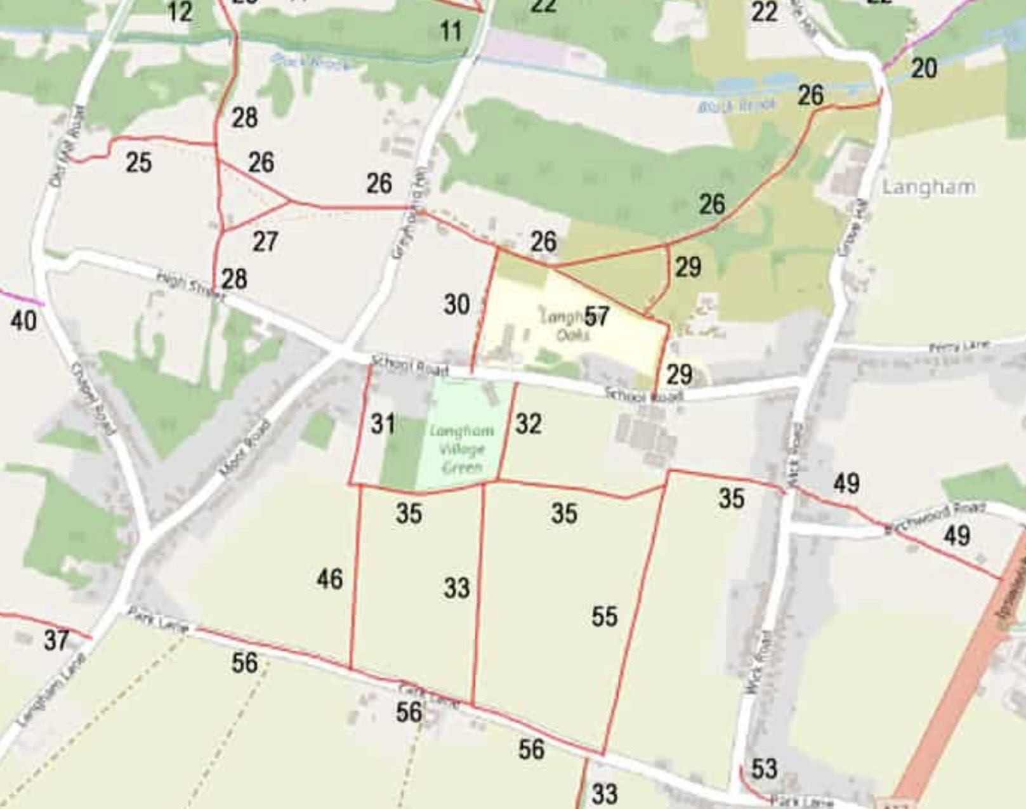
The footpaths crossing and surrounding PP37/PP38 are well-used and highly valued for recreation, rural tranquility, and connection to the historic village core. Development here would erode the sense of place and diminish community enjoyment, conflicting with NPPF 130. The footpaths affected are (31, 32, 33, 35, 46, 55 and 56) and are shown below:-

4. Heritage and Historic Landscape Context
PP37 and PP38 lie within the historic airfield landscape, extending north to the USA air force Station 150 Monument and south to the Boxted Air Museum. Together, these sites form a single historic heritage landscape. Development would harm the setting of these assets, compromise the historic understanding and experience of the airfield, and intrude into visual corridors across the parish, in conflict with NPPF 130–135, 200–209. The Monument and historical timeline information board is where respect to the American airmen who died in WW2, while based at the internationally famous Station 150, is paid annually on Remembrance Day. It is a peaceful spot, chosen as a convenient resting place for footpath walkers and because it sits symbolically by the main runway of the airfield from which young men took off to risk their lives. Langham was host to thousands of American servicemen in WW2 and the Monument and its environs are precious both to the people of Langham and to the descendants of Americans who served at Station 150. From the end of WW2 to the present day there have been frequent visits to the Monument by American families thus reinforcing the intrinsic value of this ‘undesignated’ site. (Para 201, 208-209)
The northern extremities of Station 150’s main runway and perimeter track extended across Park Lane into the site of PP37, which therefore forms a single entity with the remainder of the old airfield, now farmed land, south of Park Lane. The significance of this airfield landscape and the fact that it remains operational, has not been assessed and would be permanently and unnecessarily harmed if the 900 home development went ahead.

5. Evidence and Soundness
The Draft Plan provides no landscape-led or heritage evidence to support this allocation. There is no Landscape and Visual Impact Assessment, historic landscape character assessment, settlement pattern study, tranquility analysis, or landscape capacity assessment. Such an assessment is considered to be necessary as part of the Local Plan site allocation process to be compared with other more suitable and sustainable alternative site options. Leaving the matter to a planning application is too late in the planning process and the allocations fail the tests of soundness required by NPPF para 35.

6. Settlement Pattern and Unsoundness
The proposed developments are incompatible with Langham’s historic dispersed, semi-linear settlement pattern. Inserting a single 900+ dwelling block at the village core would effectively redesign Langham into a large car based housing estate, harming its landscape character, rural identity, and historic features. This is contrary to NPPF 35, and the allocations are therefore unsound. It should be removed from the Local Plan before the Regulation 19 stage.
In conclusion, given the inappropriate scale of development and availability of suitable and sustainable alternative development options for accommodating strategic housing growth, such a high level of harm to Langham’s environment is unnecessary and unjustified.

Langham Parish Council
12th January 2026

