Wivenhoe Town Council response to CCC Local Plan Reg 18 consultation – January 2026

Contents

Background
Site specific comments
General comments
Biodiversity impact
Biodiversity significance
Comments on biodiversity site selection
Transport
Viability
Employment
Comments on the wider Local Plan
Conclusion

Background.

This background is intended as an introduction for members of our community with no prior knowledge of the planning system. The Wivenhoe Neighbourhood Plan (WNP) is current, adopted policy of both WTC and CCC.

Both the WNP and the citywide plan, the Local plan (‘LP’) must be reviewed every 5 years. Both are current policy.

A Neighbourhood Plan is produced independently of the LP process by local groups. They can receive an overview from CCC to ensure they align with the LP.

The decision not to review the WNP before the site allocations was announced was the right one because a reviewed NP will have to be adopted by the city council. However, we do not have to accept what has been put forward by the city council.

Both the NP and the LP must comply with the National Planning Policy Framework (NPPF). It should be noted that national policy has changed since the current NP and LP were created.

The Reg 18 consultation is the opportunity to respond to site allocations and all other aspects of CCC’s draft proposals in order for appropriate changes to be embedded prior to the reg 19 consultation. This can involve changes to draft policy and site allocations.
Once the LPA is satisfied that the local plan is ready for examination it will conduct the reg 19 consultation which is done on behalf of the Secretary of State, who will appoint a government inspector to test the plan’s soundness. These are:
Positively prepared – the plan should be prepared based on a strategy which seeks to meet objectively assessed development and infrastructure requirements, including unmet requirements from neighbouring authorities where it is reasonable to do so and consistent with achieving sustainable development.
Justified – the plan should be the most appropriate strategy, when considered against the reasonable alternatives, based on proportionate evidence.
Effective – the plan should be deliverable over its period and based on effective joint working on cross-boundary strategic priorities.
Consistent with national policy – the plan should enable the delivery of sustainable development in accordance with the policies in the Framework.
Developers can also use the reg 19 consultation as an opportunity to put forward additional sites. This is when the site at Middlewick was introduced to the current local plan last time.
WTC does not believe that the current iteration of the emerging LP meets the soundness test, primarily because it does not meet with national policy, in part because the infrastructure assessment is flawed (it does not account for the negative impact of the TCBGC on Wivenhoe and the viability is at best highly questionable) and in part because it is not justified in a local context.
Site specific comments (on 10756 - Land North of the fire station)

This site provides a separation from other settlements, views towards the river, and across green fields.

Criteria (not exclusive) by which it fails the SLAA assessment are: -

- The sites are outside the existing settlement boundary, breaching policy WIV 14.
- The university have a proposal to fill the whole of the Coalescence gap with solar panels creating policy non-compliant coalescence.
- The site would have to directly access the main arterial road through Wivenhoe: Across the cycle lane which we are trying to encourage more use of.
- The site is Greenfield.
- It is Grade 2 agricultural land.
- The site is approximately 0.5km from a registered park land (Constable country) and will be visible from it.
- The site is within a Minerals Safeguarding Area.
- The site is within the Coalescence Breaks (WNP policy WIV4) See figure 1 and 1 a
- The site overlaps the River Colne Special Character Area. See figure 2 and 2a
- The site is constricted for development because of overhead pylons. See figure 3

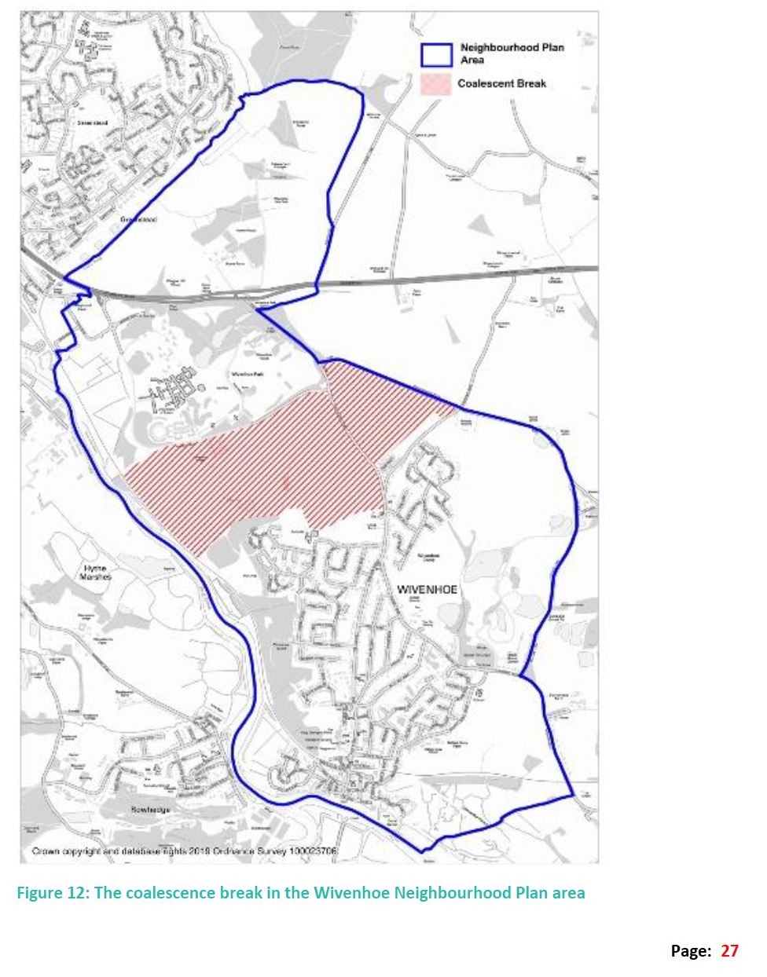 Fig 1 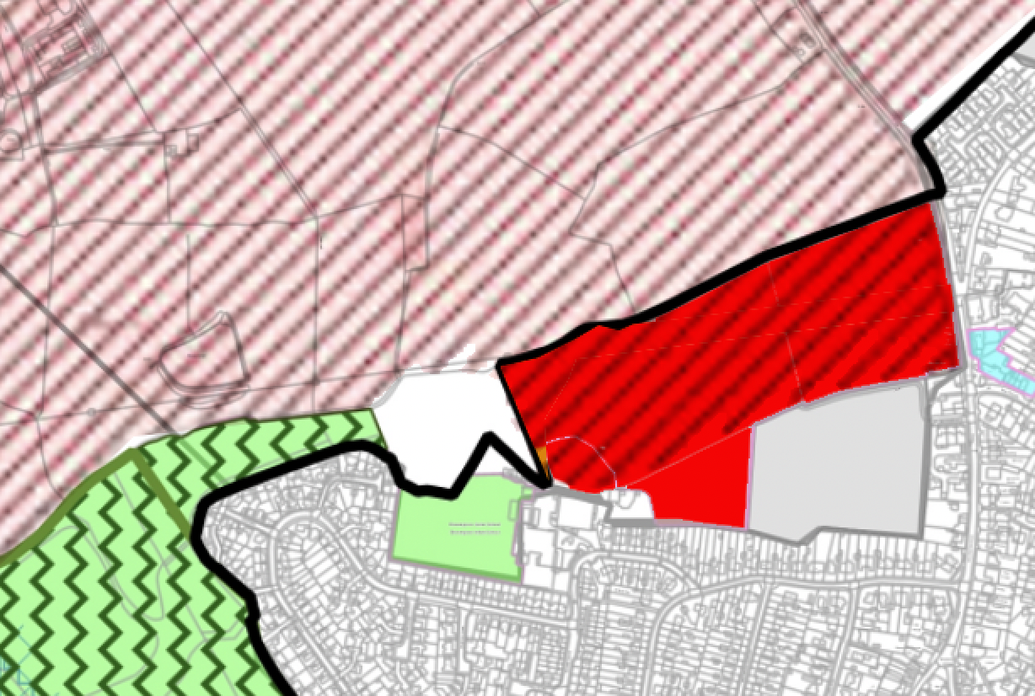 Fig 1a

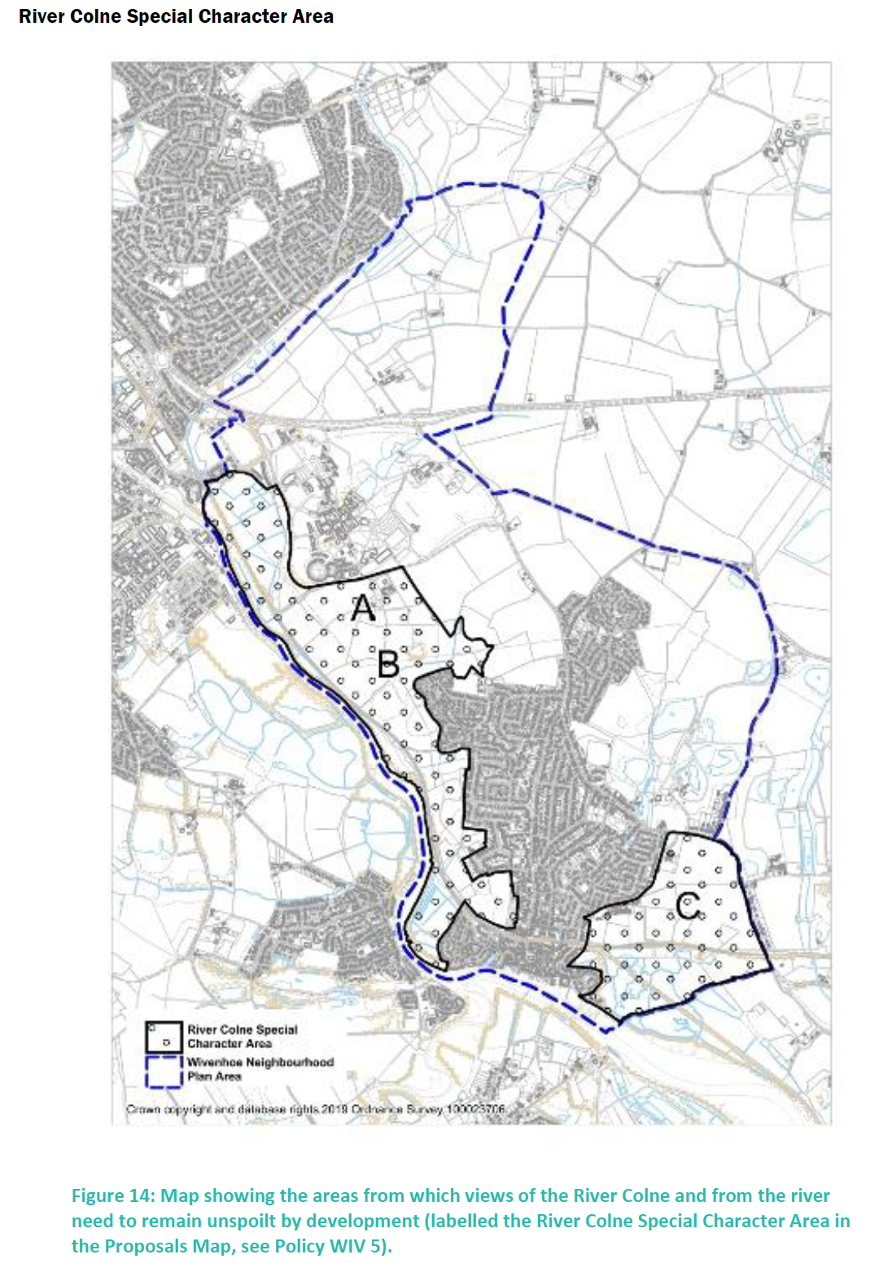Fig 2

. 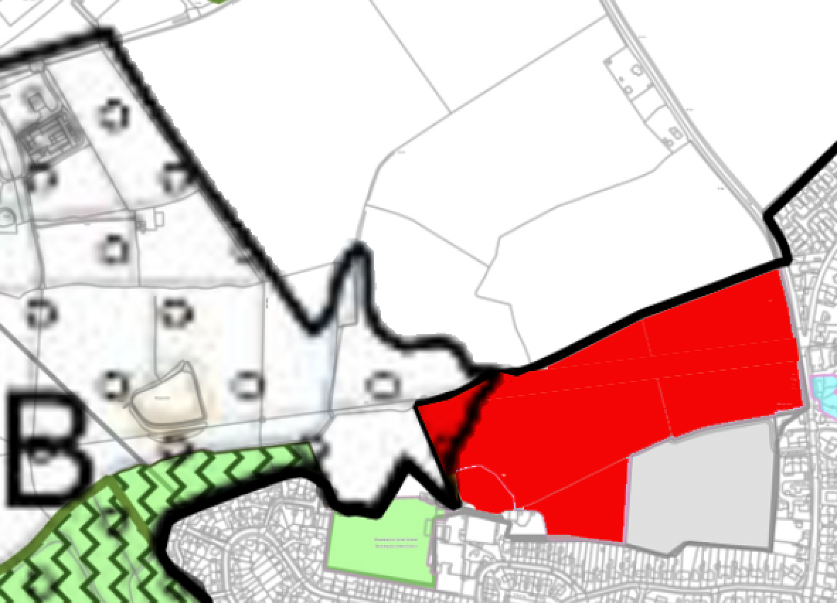 Fig 2a

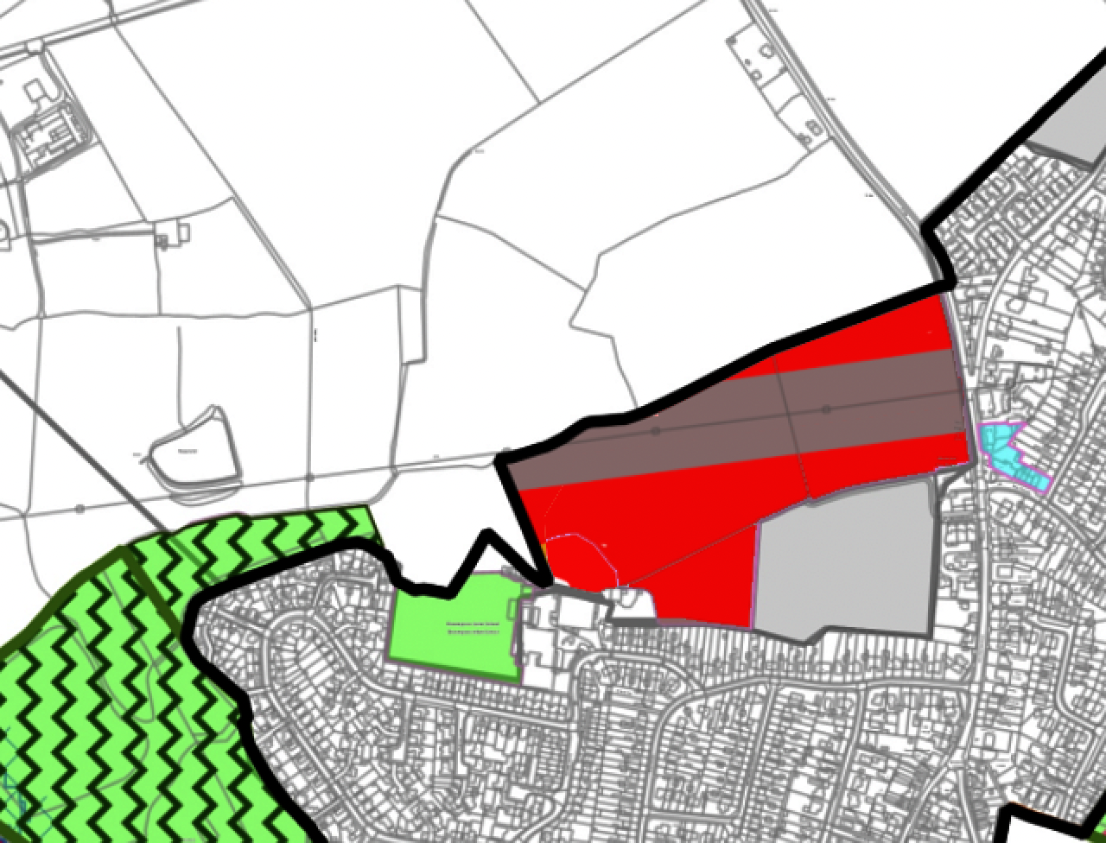 Fig 3

Additional issues with this allocation include, but are not limited to
- The green buffer does not carry round the whole of Wivenhoe which is our stated preference – see Figure 3 picture b – area 2 and 8 should join via the ‘Wivenhoe Landscape area’ and the ‘Wivenhoe borders’. The Wivenhoe Plan for Nature, which informs our Wivenhoe Neighbourhood Plan, goes into greater detail on the desperate requirement for a green corridor and is supported by third party environmental reports (which we can share on request)
- Wivenhoe has a train station, is on a major bus route and has enhanced cycle provision. In principle one of the best places for modal shift, yet it has not achieved any measurable success. Despite being one of the best places in the sub-region to establish modal shift it has not, and never will improve as there are no local jobs, local pay is low on a national scale and school places are short – more cycle provision will never fix these fundamental issues and 50% modal shift is self-evidently unobtainable.
- Buses in this corridor (and the wider context of Wivenhoe to Colchester and beyond) will always be slow and unpunctual at the very times when modal shift is most desired.
- Whole project viability is of grave concern. These concerns are not limited to the 100’s of millions of unfunded infrastructure elements in the viability assessment. Specifically, the only additional funding earmarked for Wivenhoe we can find appears to be for a mobility hub. S106 funding will need to be tailored for infrastructure we need, not what ECC want. Considerably more research needs to be done by WTC regarding this element but it is not an area of focus before the reg 19 consultation.
- The five-year review of WNP plan is on hold until this allocation is justified, creating longer term policy issues.
- The strategic biodiversity sites must be accounted for within the Wivenhoe Plan for Nature which is an emerging policy document within the WNP framework.

General Comments

Wivenhoe’s Neighbourhood Plan allocates sites for housing until 2033. These sites were based on sound evidence and this plan has been adopted as policy by Colchester.

Our NP established, as evidenced in policy, that there is insufficient infrastructure to sustain any additional homes, above and beyond the 250 new dwellings proposed in 2016. Even if it was reasonable to acknowledge the 41% uplift in housing numbers introduced by government, this should only take our existing allocation of 250 up by 102 and not 175.

The unused care facility land at the existing Cala Homes site is designated as employment land by WTC. It is viewed as a windfall site for the NP post 2033 and should not be considered in the LP.

The current situation is that there is no possibility of expanding existing infrastructure, either practically or financially to build more than the 250 allocated (now mostly built) in the current plan. E.g.:
- There is not sufficient employment within the town, and the plan offers no employment sites. This plan must reflect diminishing jobs at the University of Essex and the likely failure of the Knowledge Gateway in the context of the inability of the University to expand.
- Greater Anglia do not plan to improve the frequency of trains and commuter trains are almost always full past Colchester. We also have insufficient parking near our conservation area located train station.
- The A133 has been identified as the city’s most restricted route into the town. There are no guarantees the link road will arrive to alleviate this or even if it will hold the additional capacity required to service the traffic generating scheme of the TCBGC.
- All local primary school years are full following the development created by the NP. This does not factor in that the TCBGC will not receive a primary school for many years and ECC intend to use Wivenhoe’s stretched to capacity schools for early TCBGC residents (see purpose of school streets scheme)
- The bus service is limited, and crucially made slower and less desirable, by destinations and the increased congestion along the routes. 25 years ago, the bus took 15 minutes to Colchester town centre. The bus station to the Co-Op is now 24 minutes on the 87 and 32-52 minutes on the 51. We fail to see how this can be sold as an improvement to encourage modal shift.
- There are no NHS dentist places between here and the coast.
- There will soon be pressure from the new town on all our services and facilities. We have very limited capacity in our GP surgery (enough for the current NP only) but the new town will be within our GP’s catchment. NB Our GP surgery is in the conservation area and has no parking and constrained access.
- We have an acute shortage of playing fields for our own local clubs, however, there is no timescale for the university or the new town to build additional facilities. CCC LP’s have maxed out Wivenhoe’s infrastructure – in short there is nothing more for you to take.
- The nearest secondary school is over 2km away and we have heard examples of our preferred school (the Colne) turning students away even when they have siblings already attending.
- The five-year review of WNP plan is on hold until this allocation is justified, creating longer term policy issues.
- The strategic biodiversity sites must be accounted for within the Wivenhoe Plan for Nature which is an emerging policy document within the WNP framework.

Biodiversity impact/economic opportunity/strategic context
The town’s emerging Nature Plan identifies the natural resources surrounding Wivenhoe as a mosaic of habitats surrounding the town. Each on its own is a crucial resource for wildlife; each is a component of the town’s rural character.
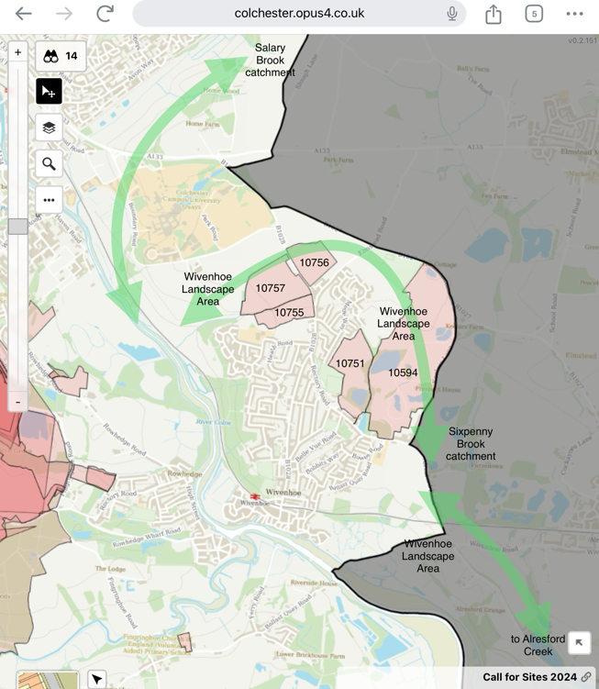
Together they create a strategic wildlife corridor.
This assemblage of habitats reinforces the social and ecological benefit of the existing coalescence gap.
It uses the planning concept of “strategic green gaps” to establish “coherent ecological networks that are more resilient to current and future pressures.” (from the NPPF)
Wildlife corridors through the Wivenhoe Landscape Area

All sites lie within the Zone of Influence for the Colne Estuary SPA and RAMSAR sites about recreational pressures.

Site specific Biodiversity significance
- Migration route and daily corridor for birds to/from the Colne flyway and feeding grounds: (birds of prey, waders & wildfowl).
- Fields host breeding Skylarks, fields and hedgerow host Cetti’s Warbler (schedule 1 species) and Nightingales (suspected breeding in 2021).
- Mature hedgerows provide foraging/transit for bats (includes European protected Barbastelle, recorded in neighbouring site summer 2023) and important land-based connectivity features across the length of the town’s Coalescence Gap.
- Margins hold populations of Common Lizard
- Rich abundance and diversity of wildflowers and rare specialist plants including Fleabane.
- Potential return of Turtle Doves (schedule 1 recent breeder).

Comments on selection for strategic biodiversity sites

We warmly welcome the selection of these strategic biodiversity sites. We have been working, via the WNP, the Planning Committee, the Plan for Nature and our Environment Committee to protect these vital habitats and we wish to make it clear we wish to work with CCC to continue to enhance these habitats. It is critical to the biodiversity, and the success of these sites, that the nature corridors are managed and not destroyed by the housing site allocation. This is noted above under site specific comments but repeated here for context, the green buffer does not surround the whole of Wivenhoe which is our stated preference – see Figure 3 picture b – 2 and 8 should join via the ‘Wivenhoe Landscape area’ and the ‘Wivenhoe borders’.

Colchester City Strategic Biodiversity Assessment - Area - 8. 5.36 to 5.38.
Between the eastern edge of Wivenhoe and the City border is a buffer of land with existing or potential value for biodiversity. At the southern end, to the south of the railway line, is part of a large block of coastal grazing marsh within the Upper Colne Marshes SSSI, which provides a link to the Roman River Valley (Area 1) and the River Colne (Area 2).
Between the railway line and Alresford Road, the valley slope of the Colne estuary is currently under arable cultivation, but sits on a superficial deposit of Kesgrave sands and gravels that would make it particularly suitable for habitat creation measures aimed at acid grassland or open mosaic habitats.
North of Alresford Road is Wivenhoe Pit, from which the same Kesgrave deposits (and others underlying them) have been extracted. This area is now a varied landscape of woodland, grassland scrub, lakes and open mosaic habitat with considerable biodiversity value. The older part of the site is designated as Co161, but most is not currently managed with nature conservation in mind and so there is opportunity to enhance the distinctiveness and condition of some of the habitats.

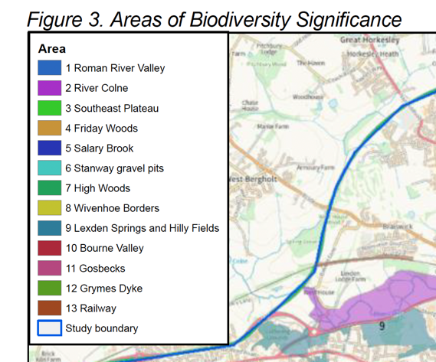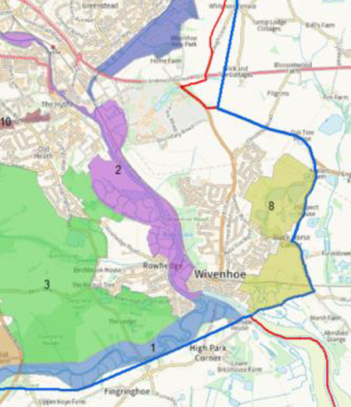
Sites of special scientific interest and local wildlife sites
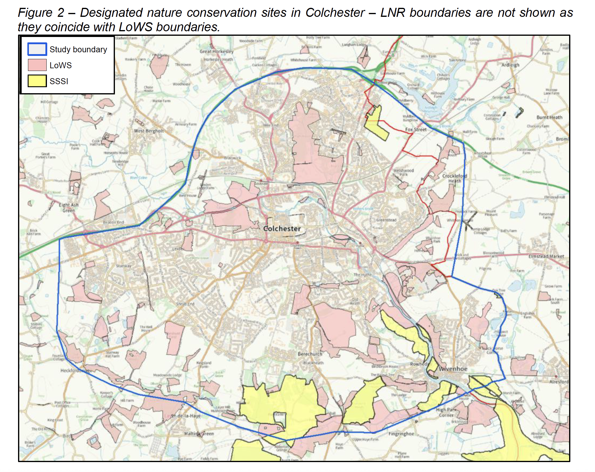
Figure 2, Designated nature conservation sites in Colchester, is a clear visual aid to understanding that Wivenhoe is surrounded by significant nature assets (including woodland and river as well as SSSI and LoWs) and that there is no space for houses and nature corridors. We believe, and can demonstrate, that these sites are equally as biodiverse as Middlewick and they are certainly as important to our residents.
Viability
There is an estimated £400 million shortfall in the viability of the LP. It remains unclear how this affects Wivenhoe. The value accrued by the selected site in s106 would be radically less than what would be required in terms of infrastructure uplift given the infrastructure deficit in Wivenhoe as described across this submission.
Transport
The LP aspiring to 50% modal shift is just an expedient as it is the only way you can massage the traffic figures and we are bored of pointing out why it will not work. We will not dwell on it here as throughout the planning process for the last local plan we pointed out its myriad flaws. The rate of cycling to work in Colchester peaks at around 2% in the summer yet ECC\CCC have been working on modal shift for a decade. It is clearly not a success. We want to know why a back-up plan or backstop for when modal shift inevitably fails is going to be seriously discussed as this policy condemns Colchester to ever worsening gridlock.
Driving out of Wivenhoe at or near peak times only serves to add traffic to the already highly congested Clingoe Hill\A133. The burden of existing and planned overdevelopment has more than accounted for any capacity perceived to exist in a desktop study.
Buses
Buses are slowest when they are most needed, at commuting times. Morning travel times between the middle of Wivenhoe and Colchester can take over 50 minutes. Buses only serve Colchester and outlaying employment areas either cannot be reached or require changes.
Cycling
WTC Travel & Transport Working Group have added the following comments.
Colchester is surrounded by very dangerous major roundabouts on all sides. There is no East-West cycle route through the town centre. Until these fundamental issues are resolved (as they have been in Chelmsford, Norwich, etc, etc) cycling will remain an unattractive option.
The LP admits that walking to work, college, etc, will not be an alternative option for most drivers.
Employment
The new residents are not buying £400k-plus two bed houses on local wages – they are almost all existing commuters from beyond Colchester and most by road – the houses will add additional car journeys through to the A133 and Colchester. It is not uncommon to find residents who drive to London to work as the train is too costly and largely impractical. These houses are not for existing local residents – most are sold by developer campaigns in London and along the A12.
There is very limited provision for employment in Wivenhoe and we urge you to consider the impact that hundreds of forecast job losses at the University will have on Wivenhoe – these will not be replaced with local jobs and residents will be forced to seek work further away and most likely travel by car.
Our NP factored in two employment sites (both care facilities) and one was not delivered.
The wider LP seeks 21,000 new jobs over the plan period. With AI, automation, the A12 being recognised as the worst road in the country and the failure of the Government to fund the widening scheme, the over expansion and subsequent decline of the sub-region’s biggest private employer – the University of Essex- this is simply absurd. Colchester City Council promised one job per house at the TCBGC – their track record in this area will never engender confidence.
We wish to reiterate that it makes more sense to build at high density near the A12 rather than forcing additional traffic though Colchester from the Tendring side.
Comments on the wider Local Plan
The Local Plan will fail, as the last one did with the botched attempt at creating three new towns, if it does not accept reality. We note that new towns were CCC’s vision of the future of strategic planning until you got one. With no little irony or vindication, we note that they have admitted this failure by not even considering a new town in this local plan. We urge CCC to learn the lessons from the abject failure of over promising and under delivering that dogged the last local plan, we especially wish to reference the clear divide with reality and this iteration.
Conclusions
Whilst we are broadly content with the strategic biodiversity sites, we strongly object to any additional housing being allocated to Wivenhoe. The allocated site does not meet with local policy nor is it consistent with national planning policy. It is not justified. It does not meet with the WNP and it hinders the progress of future iterations of the WNP. It must be removed ahead of reg 19. We note that Tendring have the courtesy to not allocate housing numbers to Elmstead Market and they state this is because of the negative and unsustainable effect of TCBGC on existing community infrastructure. That courtesy must be extended to us, especially when viewed through the prism of consistency when the two councils are set to be merged via LGR.
We remind Colchester City Council that this response must always be held in the context that we have the traffic generation scheme at TCBGC, which will leech our amenities, greenspace, road space and infrastructure.
These site-specific policy inconsistencies are laid out on page 5. We draw your attention particularly to our ‘village envelope’ and we remind you that WTC have always considered this to be our red line as we have a long-standing fundamental aim to ensure against coalescence.
Wivenhoe is surrounded by the natural break created by the A133, our coalescence break, a river, SSI sites, LOWS, roman woodland and rules around our conservation area and sites of historical importance. There is simply no room left for this level of development and what little there is must be reserved for the WNP, for example the Cala Homes windfall site cited above.
The general site comments, on page 4 highlight how the plan is not justified nor positively prepared and this is further evidenced with comments on additional issues on page 10. This is not an exhaustive list and we retain the right to draw on these matters and others, should we need to represent ourselves at the reg 19 hearing.

