Colchester Cycling Campaign email

Would you please add this to the Colchester Cycling Campaign submission?

We would like to see this footpath (see map) earmarked for a full cycleway to link Langham Lane with the path into the Northern Gateway.

Realistically this section of Severalls Lane is likely to remain busy with cars.

Should Langham Lane be made subject to a “residents only” filter as part of the proposed housing development, then this short section of path could provide a safe way to join the Northern Gateway path network.

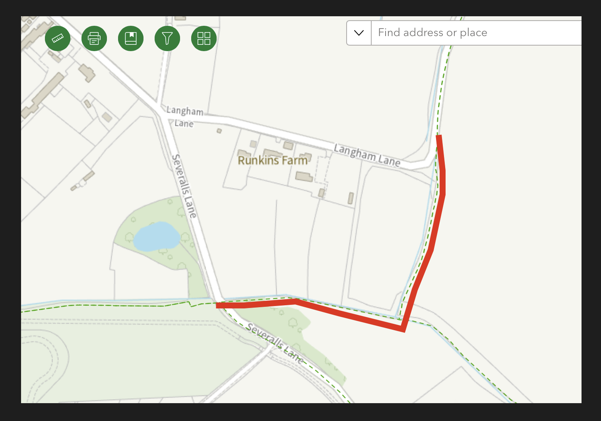

Best wishes,
Will

Secretary, Colchester Cycling Campaign

